**PsyBSc 11: Emotion 1a (Vorlesung 1)**

Themen Emotionen 1b: Strategies of Emotion Regulation

# Emotionsregulation

## Definition

Emotion regulation according to Gross (2002) comprises processes that allow us to influence…

1. which emotions we have,
2. when we have them,
3. how we experience them
4. and how we express them.

## Ein Bild, das Tisch enthält. Automatisch generierte Beschreibung1.2 Emotion regulation strategies by Parkinson & Totterdell (1999)

Two dimensions:

1. Implementation medium: cognitive or behavioral
2. Intention strategy: diversion or engagement

Can you think of strategies for each cell?

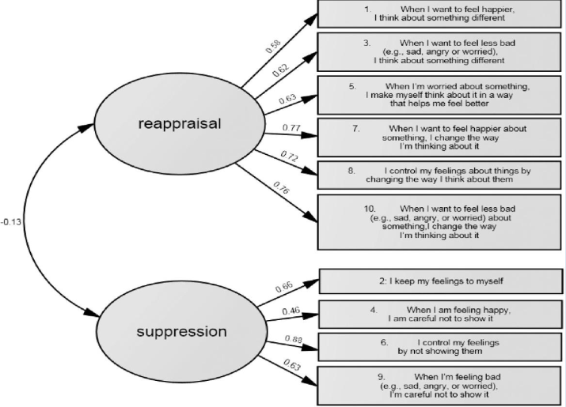**Item examples for emotion regulation strategies**

## Process model of emotion regulation by Gross (1998, 2007)

This is another attempt at classifying emotion regulation strategies which also considers that processes happen in a temporal oder.

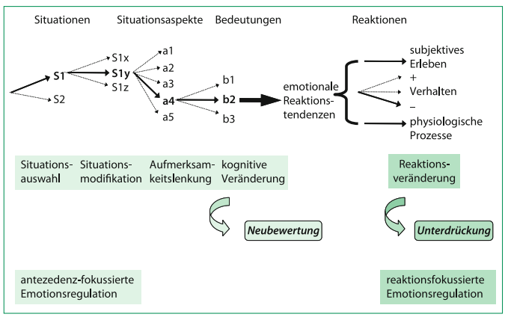

Gross distinguished antecedence focused processes (early) and reaction focused processes (later).

1. Antecedence focused strategies

Strategies that are deployed early, before an emotion has reached all reaction components.

1. Situation selection: avoid situations that evoke negative emotions, seek for situations that make you feel good
2. Situation modification: you can influence the situation you’re in (e.g., telling the dentist of your anxiety and he uses another procedure)
3. Attentional deployment: divert attention from emotional stimuli of an environment (don’t pay attention to what the dentist is doing in your mouth, think about your vacation)
4. Cognitive change: we can interpret a situation in such a way that it evokes different emotions (e.g., “this procedure is necessary for my dental health and I should be grateful to receive it”
5. Response modulation
6. Regulation of physiological arousal: cigarettes, sweets, sports, biofeedback, beta-blockers (blood pressure medicine that reduces heart racing, flushing, sweat)
7. Regulation of subjective experience: either suppressing a feeling or paying intense attention to it, ruminating
8. Regulation of emotional expressive behavior: your expression of emotion can either be enhanced or dampened/suppressed
9. Expression/engagement: emotional experiences can be processed by writing them down

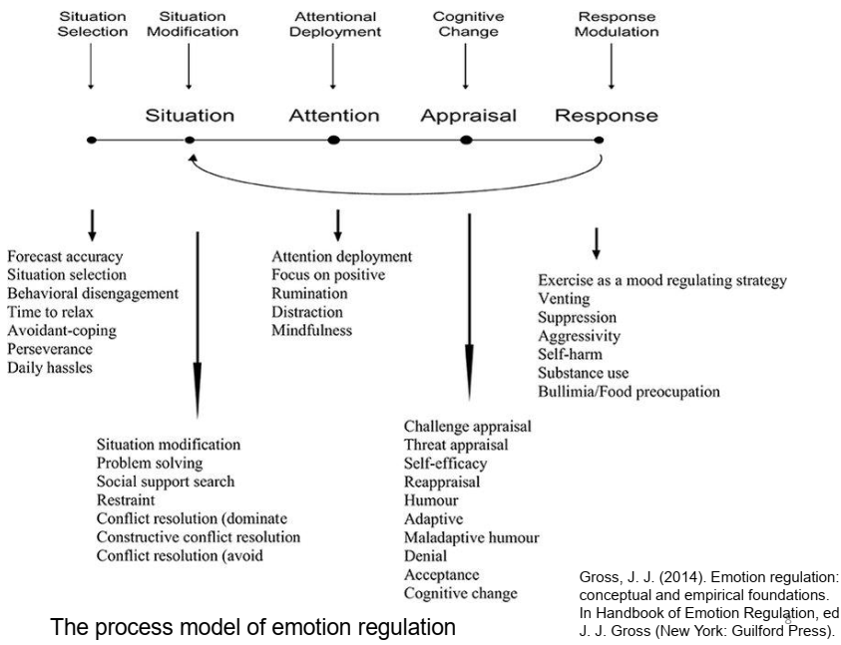

## Model by Bonnano & Burton (2013)

## 

### 1.4.1 Adaptive of the strategy depends on context (Barnow et al., 2020)

1. Intensity of emotion (+ distraction)
2. Number of stressors (high: - reappraisal)
3. Regulatory goals (assertion vs. avoidance of conflict)

* E.g., if you argue with your partner, you might want to be more assertive and confrontational than when you are talking to your boss

1. Controllability (grief vs. problem solving)

* Maybe no intervention might be a more adaptive strategy than trying to suppress or excessively analyze the felt grief

## 1.5 Her opinion

* Linear, straightforward models of cognitive-affective motivational processes without any feedback are always incomplete
* Models with feedback are harder to falsify: cause and consequence are blurred and form a loop
* What process is better (more adaptive) always depends on goals/context/individual differences
* Some people are rather sensitive, others more repressive
* Using an assertive process may be hard for repressors in that moment but using it may pay off in the long run: Does someone want a quick fix for their problem or do they want long time improvement? Therefore, processes depend on timing as well

# 2. Methods of emotion research

## 2.1 Manipulation of emotions (UV)

1. Presentation of affective stimuli (words, images, sounds) to induce perception/processing of emotions
2. Mood induction procedures (films, music, texts, facial expressions, smells, noise, environment)
3. Reward and punishment (to induce approach or withdrawal)

## 2.2 Measures of emotion (AV)

1. Cognitive: Self-report, rating scales (PANAS = positive affect negative affect scale)
2. Behavioral: behavioral indicators (preferences, response times, FACS)
3. Physiological: Peripheral (EDA, EMG, EEG, cortisol) and CNS indicators (EEG, fMRI)